Worksheet 1

1. Models of Cyclodextrin Molecules

Examine the Flash animations with the structural models of cyclodextrin molecules and decide which model type(s) best explain(s) the property described. Rate the usefulness with ++, + or -.

 | Truncated  cone | Cyclic oligo-saccharides | α-Glycosidic linking of the glucose units | Groups where hydrogen bonding is possible | Charge distribution in the molecule | Hydrophobic interior and hydrophilic exterior
Rod model
Surface model
Surface-rod model
Ball-and-rod model
Space-filling model
Surface model with electr. potential

2. Surface Model with Electrostatic Potential

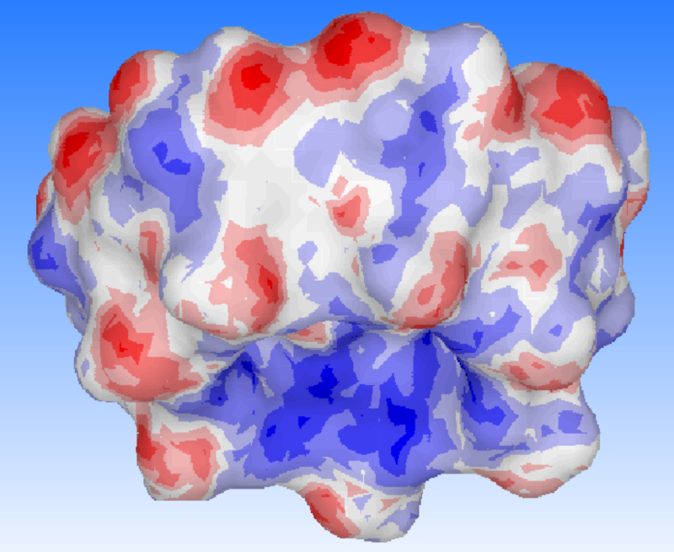  β-Cyclodextrin molecule in the surface model with electrostatic potential | 2.1 Which color corresponds to increased electron density?  Give reasons.  2.2 Compare the red-blue color shift on the outside and that on the inside of the molecule and use it to explain the hydrophilic and hydrophobic properties.

Worksheet 2

Host-Guest Complex of β–Cyclodextrin and Phenolphthalein PP

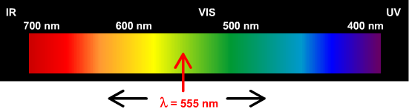
- The arrow indicates the wavelength of the light that is absorbed most strongly by PP in alkaline solution. In which direction is the absorption maximum of PP shifted when it is complexed with cyclodextrin? To the right or to the left? Cross-out the incorrect arrow. Give reasons for your answer using the experimental observation and by observing the Flash animation.

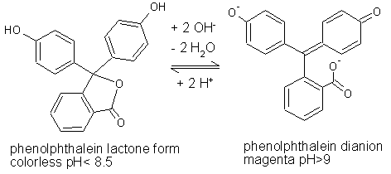 | - Referring to equilibrium in the formula, give reasons why PP is an acid-base indicator and explain the different colors.

- Complete the double bonds in the indicated formula with reference to the Flash animation  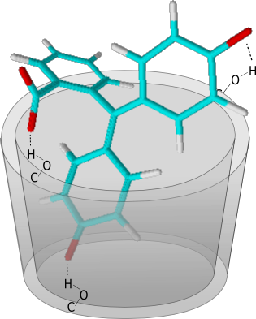 | - Compare the form of the PP in the complex with the lactone form from exercise 2. Mention one structural feature they have in common, and one difference.

Worksheet 3

Cyclodextrins in Textile Finishing

- The textile of the sofa has been treated with cyclodextrin and can absorb pleasantly scented substances. Explain that fact using the results of the Cyclodextrins in Textile Finishing experiment shown in the right-hand picture | 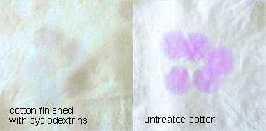

- In the Cyclodextrins in Textile Finishing experiment, the cyanuric chloride “anchor molecule” and β–cyclodextrin form monochlorotriazinyl-β-cyclodextrin in alkaline solution. Name the reaction type and explain why this intermediate can bind to the cotton fibers better than β–cyclodextrin. | 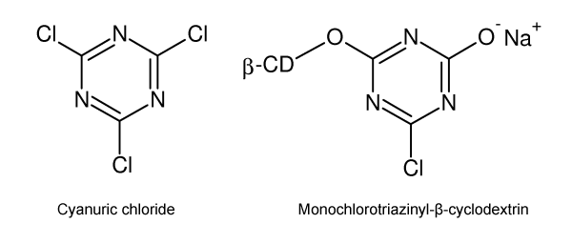

- The tetracarboxylic acid formulated below can also be used as an "anchor molecule" between cotton and cyclodextrin. Explain why, and name the reaction type.
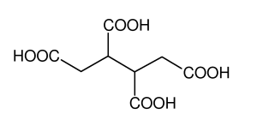

Worksheet 1 - Solution

1 Models of Cyclodextrin Molecules

Examine the Flash animations with the structural models of cyclodextrin molecules and decide which model type(s) best explain(s) the property described. Rate the usefulness with ++, + or -.

 | Truncated  cone | Cyclic oligo-saccharides | α-Glycosidic linking of the glucose units | Groups where hydrogen bonding is possible | Charge distribution in the molecule | Hydrophobic interior and hydrophilic exterior
Rod model | - | ++ | ++ | ++ | - | -
Surface model | ++ | - | - | - | - | -
Surface-rod model | + | + | + | + | - | -
Ball-and-rod model | - | + | ++ | + | - | -
Space-filling model | + | + | - | + | - | -
Surface model with electr. potential | ++ | - | - | ++ | ++ | ++

2. Surface Model with Electrostatic Potential

β-Cyclodextrin molecule in the surface model with electrostatic potential | 2.1 Which color corresponds to increased electron density?  Give reasons.  The color red corresponds to higher electron density in the molecule, because it appears wherever electrically negative oxygen atoms occur in highly polarized hydroxy groups.  2.2 Compare the red-blue color shift on the outside and that on the inside of the molecule and use it to explain the hydrophilic and hydrophobic properties.
The red-blue color shift is pronounced on the outside, i.e. the change between partial positive and partial negative charge occurs frequently. That makes the outside hydrophilic. The inside is almost entirely in one color, and is therefore highly non-polar. That correlates with the hydrophobicity of the inside.

Worksheet 2 - Solution

Host-Guest Complex of β–Cyclodextrin and Phenolphthalein PP

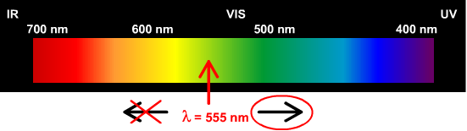
1. The arrow indicates the wavelength of the light that is absorbed most strongly by PP in alkaline solution. In which direction is the absorption maximum of PP shifted when it is complexed with cyclodextrin? To the right or to the left? Cross-out the incorrect arrow. Give reasons for your answer using the experimental observation and by observing the Flash animation.
It is experimentally observed that complexed PP is colorless. The Flash animation shows how the system is twisted with the development of the three hydrogen bridges and explains why this affects the delocalization of the π-electrons. In the complexed PP-dianion, the chromophore is shorter than in PP dianion in solution.

2. Referring to the equilibrium in the formula, give reasons why PP is an acid-base indicator and explain the different colors.
PP is an acid-base indicator because, due to the protolysis reactions shown in the formula, it occurs reversibly in either the protonated, colorless lactone form, or as a red-violet dianion, depending on the pH of the solution.

3. Complete the double bonds in the indicated formula with reference to the Flash animation  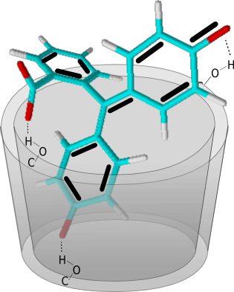 | 4. Compare the form of the PP in the complex with the lactone form from exercise 2. Mention one structural feature they have in common, and one difference.  Common feature: The PP as dianion and the PP in lactone form are both non-planar, since the three rings are arranged mutually twisted around the central carbon atom.  Difference: The two forms differ according to the extension of the system of conjugated double bonds. While, in the dianion form, the π electron system extends across all rings, in the lactone form, the conjugation is interrupted at the central carbon atom.

Worksheet 3 - Solution

Cyclodextrins in Textile Finishing

1. The textile of the sofa has been treated with cyclodextrin and can absorb pleasantly scented substances. Explain that fact using the results of the Cyclodextrins in Textile Finishing experiment shown in the right-hand picture | The cyclodextrin molecules can accommodate molecules in their cavity. In the experiment, the cyclodextrins bound to the cotton fiber are detected with alkaline phenolphthalein (PP) solution. The PP solution is discolored, since the PP is complexed with the cyclodextrin molecules. This changes the three-dimensional structure of the PP dianion, so that the color disappears.

2. In the Cyclodextrins in Textile Finishing experiment, the cyanuric chloride “anchor molecule” and β–cyclodextrin form monochlorotriazinyl-β-cyclodextrin in solution. Name the reaction type and explain why this intermediate can bind to the cotton fibers better than β–cyclodextrin.
This is a double nucleophilic substitution, in which two Cl⁻ radicals in the trichlorotriazine molecule (cyanuric chloride) are substituted by an OH⁻ radical and a β–CD-O⁻ radical. Since the reaction takes place in alkaline solution, the product occurs in the form of the sodium salt. The anion of this salt is in turn a strong nucleophile, which reacts better with C-OH groups on the cotton fiber than cyclodextrin itself.

3. The tetracarboxylic acid formulated below can also be used as an "anchor molecule" between cotton and cyclodextrin. Explain why, and name the reaction type. | The tetracarboxylic acid can condense with cyclodextrin to form ester groups on the one hand and on the other hand esterify with hydroxy groups from cellulose molecules. It can therefore act as an anchor between cyclodextrin and cellulose.

